Who we are

The Golden Connections Community Center is a multi-service facility for 60 or older adults. The center can fulfill many social, emotional, and intellectual needs. Center activities are designed to overcome loneliness, enhance self-esteem, encourage personal growth, and to facilitate independence through involvement.
We believe that:
- Every person is valuable
- Older adults want to be self-sufficient
- Self-sufficiency is better than dependency
- Survival needs must be met for personal growth and stability
- Everyone deserves respect, opportunities, and fair treatment
- Agency resources should effectively benefit the people served
- Responsible organizations use resources appropriately, effectively, and efficiently
- Committed staff and volunteers are valuable assets
- A strong community is responsible for supporting all its members
- Success is dependent on teamwork
- Empowered people enrich their own lives and that of their communities
- Community involvement is “People Helping People”
Programs & Services

Meal Programs
- Congregate Meals and Home Delivered Meals

Exercise Programs
- Strength Training, CBS (cardio, balance, strength), Cardio Drum, Qigong, Yoga, Feel the Beat ( dance cardio), and Line Dance

Wellness Programs
- Matter of Balance, Nutrition and Wellness Speakers, Blood Pressure Checks, Chronic Disease Self-Management, Diabetic Support and Mind Matters

Lifelong Learning Programs
- Technology Education, Support Groups, Book Clubs, Arts and Culture Programs

Assistance Programs
- Rent and Property Rebates, Energy Assistance, Insurance Help, Unemployment Support, Veterans Support, and Notarization Services

Center Rentals

Our mission expands beyond the older adults that attend our center each day. Various community organizations use our facility to hold meetings and workshops. Groups include:
- Solomons Church
- Stix N Tones Drum classes
- Community Line Dance Workshops/Classes
- York County Board of Elections
- Individual Community Members for family Functions

Contact Us

20 Gotham Place
Red Lion, PA 17356

Phone: 717-244--7229
Facebook: www.facebook.com/goldenconnectionscommunitycenter
Website: www.gcccenter.com



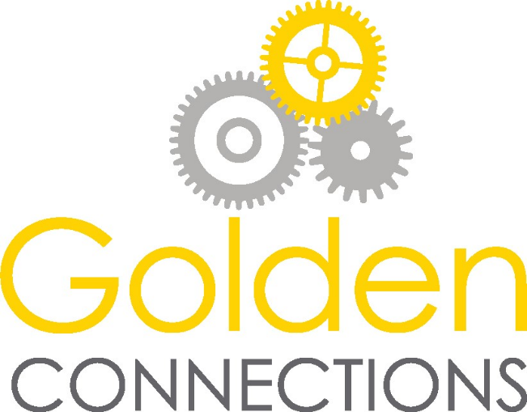
Sponsorship
Packet

Normal Operating Budget

Income Expenses
54% York County Area 43% Personnel costs
Agency on Aging 26% Occupancy Costs
12% Fundraisers 20% Programming Expenses
10% Municipal Support 7% Supplies
9% Community Donations 4% Legal
7% Building Rentals
6% Grants
2% Programming

Statistics

* We serve over 21,000 congregate lunches in a year.
* We serve over 33,500 meals through our meals on wheels
program each year.
* Average of 120 seniors walk through our doors every day.

Why do we need sponsors?

Our mission is to make a positive difference in the lives of older adults living in our community. We accomplish this by offering interesting programs in a warm a welcoming setting. However, our membership is steady growing. This has led to the center to actively pursue a variety of fundraising ideas.
To continue to offer vital services to everyone, we must expand the way we raise funds. Sponsorships will allow us to continue to provide the services our members have come to rely upon, without asking for any out-of-pocket funds from them.

Rules for Sponsorship

- All organizations must sign up for a sponsorship package or they will not be able to present information to center members.

- All materials and advertisements must be proof-read/approved by the Director of Social Services prior to publication.

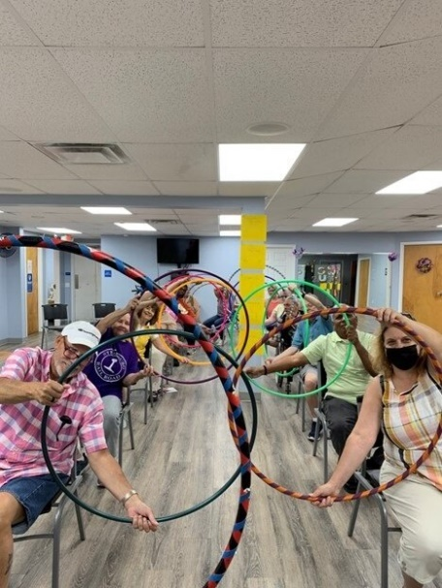
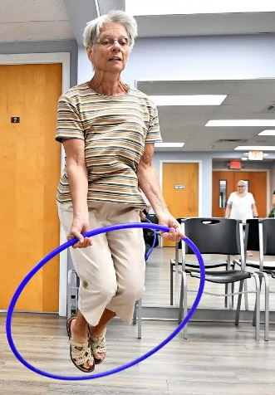
How will your organization benefit?

Various Sponsorship levels are available for your business.
Depending on your level of sponsorship, you will be entitled to:
- Place advertisements in the monthly newsletter that is read by hundreds of older adults in York County.
- Place advertisements on the center’s website and Facebook page.
- Place advertisements on the daily television presentation.
- Onsite marketing opportunities with center members.
- Ability to place promotional flyers, business cards, and brochures in the main community room.
- An invitation to have a promotional table at all community events.

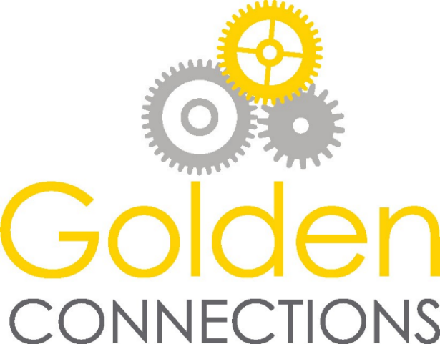

Annual Sponsorship Menu
Level & Benefits | Platinum  Sponsor  (1 Year duration)  $2,000 | Gold  Sponsor  (1 Year duration)  $1,000 | Silver  Sponsor  (6-month duration)  $500 | Bronze  Sponsor  (3-month duration)  $250
Company Logo placed on community event material’s, such as website, Copilot, & daily television presentation for duration on your sponsorship. | X | X | X | X
Advertisement space is available in each newsletter. | X  Plus  E-Newsletter | X | X | X
1 Advertisement displayed daily on the daily television presentation and Copilot | X | X | X
1 Advertisement displayed monthly on the center’s Facebook page. | X | X | X | X
Your company events and a link to your organization’s website will be placed on the Golden Connections Community Center website. | X | X | X
Presentation opportunities. | X  6/sponsorship | X  4/sponsorship | X  3/sponsorship | X  1/sponsorship
Invitation to have promotional table in a shared space at community events (examples: Basket BINGO, Street Fair, Vendor Fair and Golf Outing | X  All | X  Vendor Fair ONLY
Display company brochures and information in the main community room. | X | X | X | X
The opportunity to join the Golden Connections Community Center for 1 center celebration (ex. Holiday party) where the sponsor is highlighted as a sponsor of the center. | X | X
Other sponsorship opportunities are available and include E-News & Marketing publications.
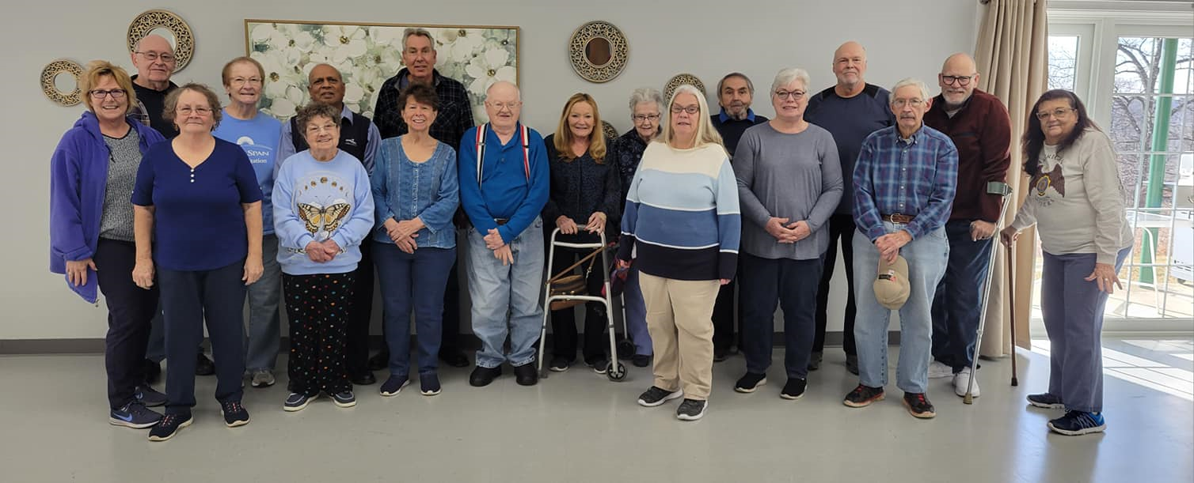
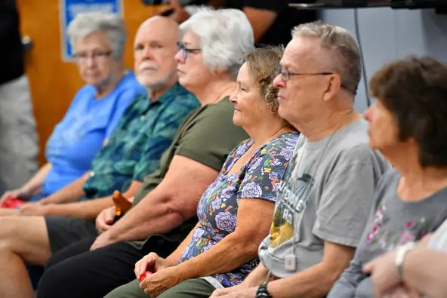
The Golden Connections Community Center would be honored to have you join as a GCCC Sponsorship Partner. If you are interested in becoming a sponsor, please complete the Sponsorship Agreement and return to:

Amanda Pina
Golden Connections Community Center
20 Gotham Place
Red Lion, PA 17356
socialservices@gcccenter.com

To further discussing a sponsorship, please contact Amanda Pina, Director of Social Services, at 717-244-7229 ext. 103 or at socialservices@gcccenter.com .

